International University
Vietnam National University - HCMC



POKEMON GAME PROJECT

Lecturer: MSc. Nguyen Quang Phu
Student: Nguyễn Minh Quan – ITITIU18271

Introduction:
- Nowaday, with the speed up rapidly of Software Technology industry, the high level in programming skill is more necessary. So the classic Procedural-Oriented Programming method can not be responsed completely for all requirements. That leeds the invention of a new method followed the principle Alan – Kay named “Object – Oriented Programming” to overcome this cases.
- This project was designed based on Object – Oriented Programming method by Java language. So this has solved some problems that was occur while building by common Procedural – Oriented Method:
- The code is clear, easy to understand and concise.
- The project is a unified logic system by many related - Classes combine together.
- Each Class has many Methods which take on different bahviors of own class.
- The ability of reusing the resoureces.
- The purpose of this project is to desgin a basic game that was build on foundation of object – oriented. Our group decided to modify a game named “Pokemon” follow the principle of this method. This game will show clearly the object – oriented property, the combination of classes, between class and object. Tetris is a game require the user to arrange different shapes of cubes in order to there is no empty in a line. Although Tetris has appeared for a long time, our Pokemon has been developed with new design, speed of the game, not require the configuration of the computer and specific is this game is build based on the Object – Oriented Method.
- Morever, besides the demand we have mentioned above, we also want to create this project to practice all the techniques we have acquired during this course such as working with Class, Object and how to implement the problem by OOP method logically, ect. Furthermore, we event want to improve ourselves by the application of new algorithms to make our software run more effectively. Although we are fully aware of the risk and some difficulty when we utilize some knowledge outside the university syllabus, we still want to challenge ourselve to get acquantained with the real pressure in the workplace in the future. To put it another way, the bottom line here is that we desire to make a step further on our way to ultimately become an advanced and professional software developer.

Basic Elements:
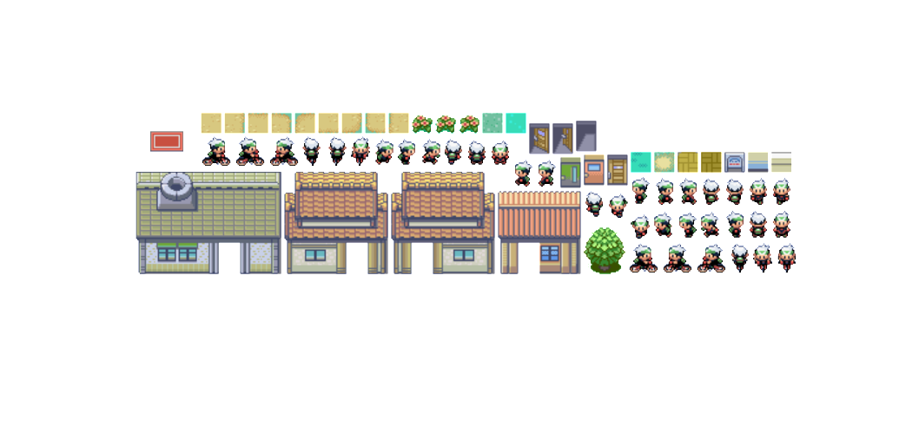
Figure 1: Objects in game

Figure 2: UI in game
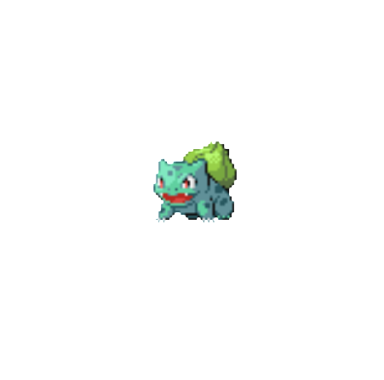
Figure 3: Pokemon in game

Functions:

Actor:
- To perform action like running around, we add some functions to move and have a bike for actor.
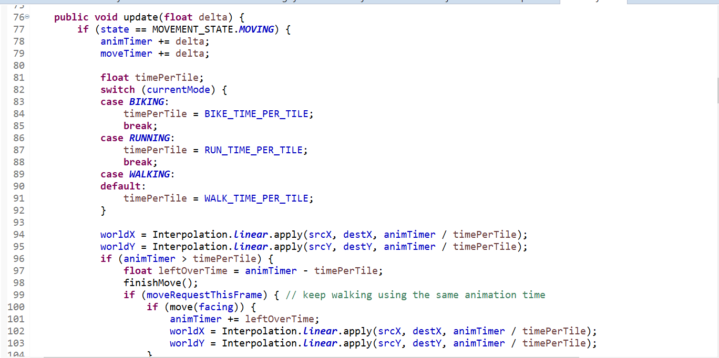
Figure 4: Set coordinate for actor
- Map:
- We have created 2 maps: Littleroot_town and Oldale_town for the character moves between two maps.
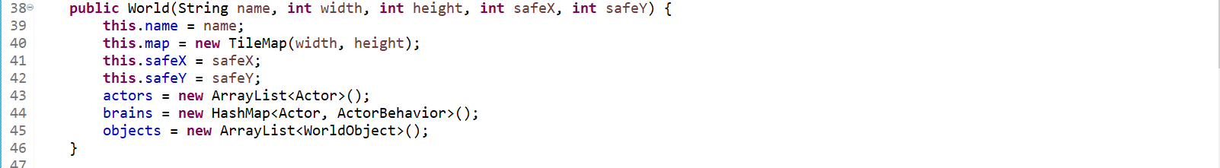
Figure 5: Create world
- Battle:
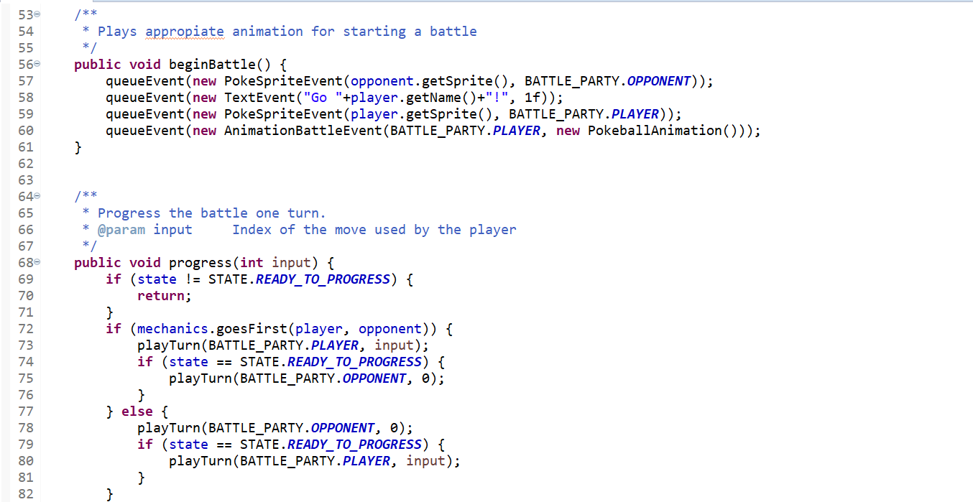
Figure 6: Create battle
- Music:
- We add music and a loop

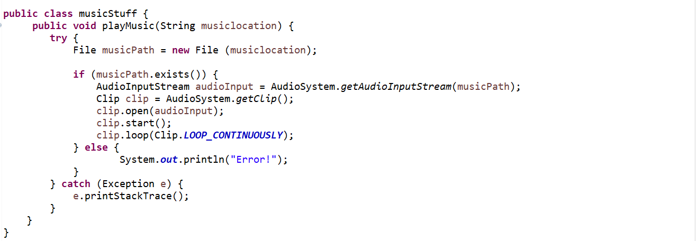
Figure 7: Music in game

Result:
- Based on principle of OOP Method, our project has been completely with basic rules and properties of Tetris game. The combination of classes and objects in system is relative logically.
- We will also add some new features out of the basic rule is the button to change sound in game, some buttons to pause, stop, refresh. The user interface is more attractive and easier to use.
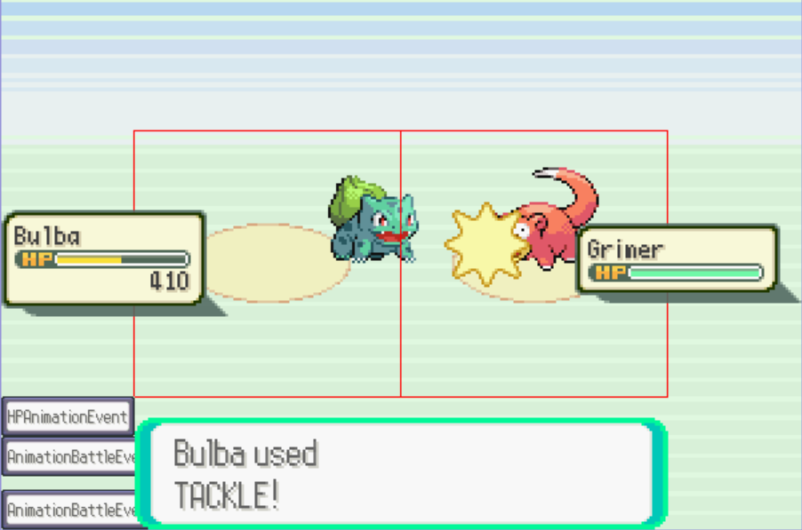
Figure 8: Battle in game

Conclusion:
Pokemon Game that was build by object – oriented method is easier and locially than traditional – method. This shows cleary polymorphism, inheritance, encapsulation, data abstraction of OOP and the realationship between Shape, Board or other shapes together is linked tightly and systematically. Besides that, learning more knownledge out of the limited of this course is one of the important things to do while performing this project.

